Concurrency :- lamen term means doing multiple task simultenously.

Advantage:

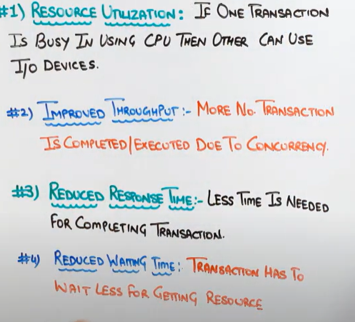

Eg

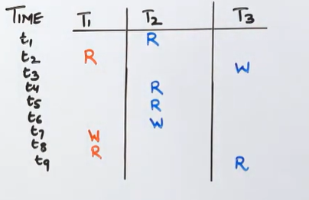

Here

In Concurrency

T2🡪T1🡪T3🡪T2🡪T1🡪T3

IN serialization

One transaction is completed than only other transaction will start doing rollback commit .

Time line:

T2🡪T1🡪T3

Disadvantage of concurrency:-

🡪**Loss Update Problem**

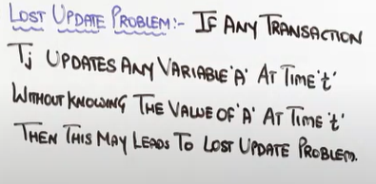

Eg

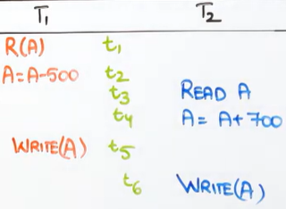

According to given time Tj the values would be

|  |  |  |
| --- | --- | --- |
| T1 | Time | T2 |
| 2000 | t1 |  |
| 1500 | t2 |  |
|  | t3 | 2000 |
|  | t4 | 2700 |
| 1500 | t5 |  |
|  | T6 | 2700 |

Since actual value of T1 to be taken in reading A was 1500 but since write function was used at t5 time so updation went wrong.

🡪**Dirty Read Problem**

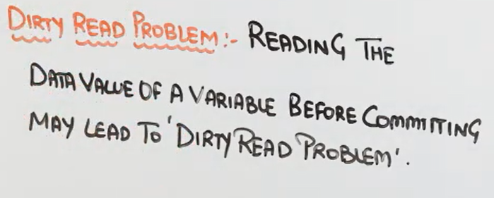

[**https://quescol.com/dbms/lost-update-problem-dirty-read-problem**](https://quescol.com/dbms/lost-update-problem-dirty-read-problem) **: dirty read example will give you better understanding**

**if not then here is case study example**

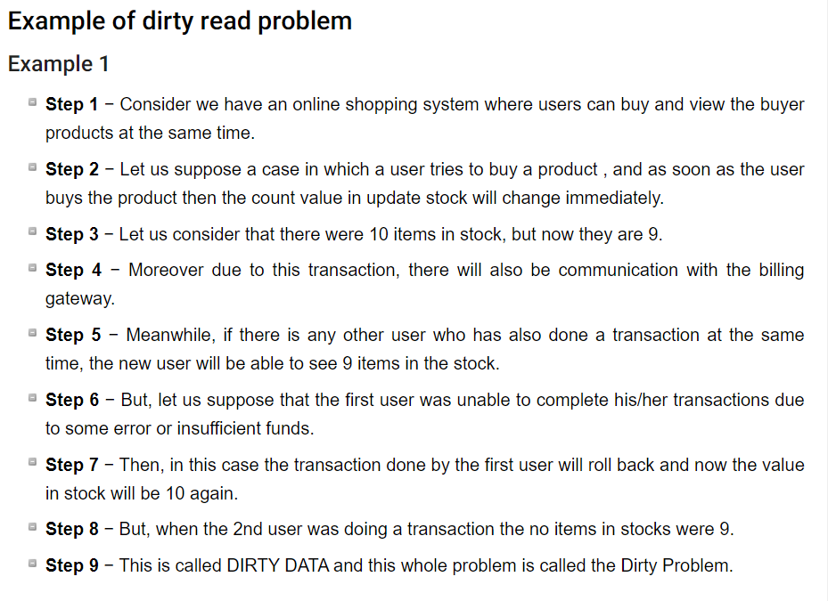

**🡪Uncommited depenedency Problem**

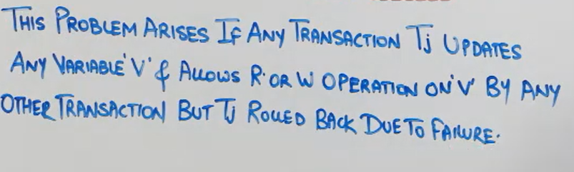

**Dirty read and uncommited both r same in lamen terms**

**🡪Unrepeatable read problem**

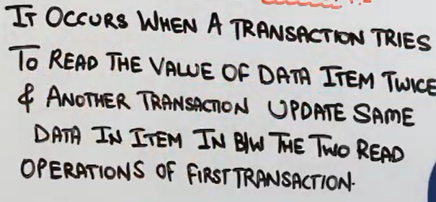

**Eg**

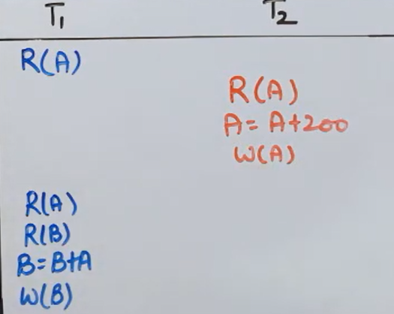

**Looking toward following time ,**

**Suppose A=500**

|  |  |
| --- | --- |
| **T1** | **T2** |
| **500** |  |
|  | **500** |
|  | **700** |
|  | **700** |
| **700** |  |
| **600** |  |
| **1300** |  |
| **1300** |  |

**Here no dirty read and uncommitted issue but the acid property that is isolation is break.**

**Isolation property says no two process can see others values during the process.**

**But here T1 read A twice and gets another values one is 500 and other is 700 since 700 wll be stored in db but isolation will be breaked.**

**🡪Inconsistency Analysis Problem**

**Eg**

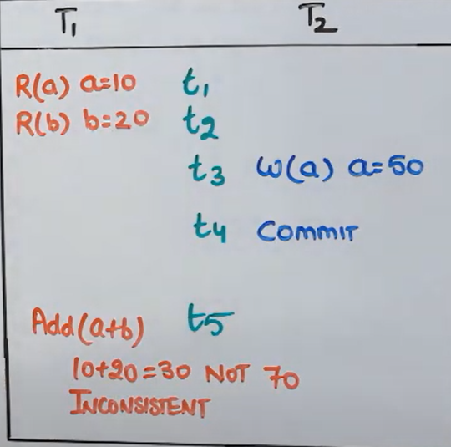

**After commiting t2 the new value of a is 50 but since T1 has read the updated value the function(a+b) will function(10+20) and not (50+20)**

**Not reading the value after committed by another transaction is called inconsistency problem.**

**🡪Phantom Read Problem**

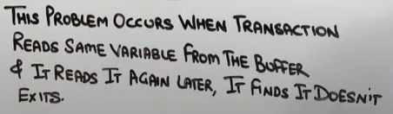

|  |  |
| --- | --- |
| **T1** | **T2** |
| **Read A** |  |
|  | **Read A** |
| **Delete A** |  |
|  | **Read A** |

**Here suppose transaction A has 50 .**

**T1 T2**

**50**

**50**

**0**

**0**

**T2 doesn’t know why value of a is 0 if he knows than isolation property will be affected.**